 | Universidad Autónoma de Nuevo León  School of Mechanic and Electric Engineering  Coordination of Management and Systems  Programming Academy

Software Technologies Engineering
Adaptive Systems Programming


Team | Kepler
Student id 1 | Name 1
2057220 | Diego Enrique Vega Lara
…
…

Prof. Sara Elena Garza Villarreal, PhD  January-June 2025  San Nicolás de los Garza, NL | 

Neural Networks
  - Report 3.C.2

General instructions. Solve each exercise along with your team.

Prediction: Variable types
Instructions. For each feature, indicate its variable type (Titanic data set).
Feature | Type (numerical/categorical)
Passenger id
Boarding class
Sex
Age
Fee
Survived?

Classification
Instructions. Formulate a classification problem. Describe its context. Indicate which objects are to be classified, which features are being considered, and the set of classes.
Context
Objects
Features
Classes

Multilayer neural networks
Instructions. Solve the exercise presented in the document Neural Networks with sklearn. Fill out the table with your results.

Flow (fragment ordering)

Fragments
Fragment label | Description | Output

Deep neural networks
Instructions. Modify the code presented in the notebook digits_v240429.ipynb. This code classifies digits by means of a convolutional neural network (Keras library). Generate one model per every two members of the team (e.g., if the team consists of 6 members, then 3 models will be handed in). If the team has an uneven number of members, then one member will generate a model individually. You may only modify the code that corresponds to the neural network model (see Figure 1). Place in this document, for each model, its design, a screenshot with the training of the network, and the accuracy obtained. To run the code, you may either download Keras or use Google Colab (https://colab.research.google.com).

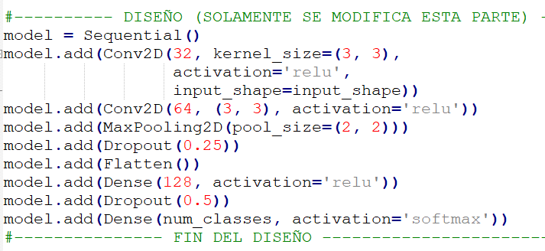
Figure 1. Code to modify

Model 1
Code (design)
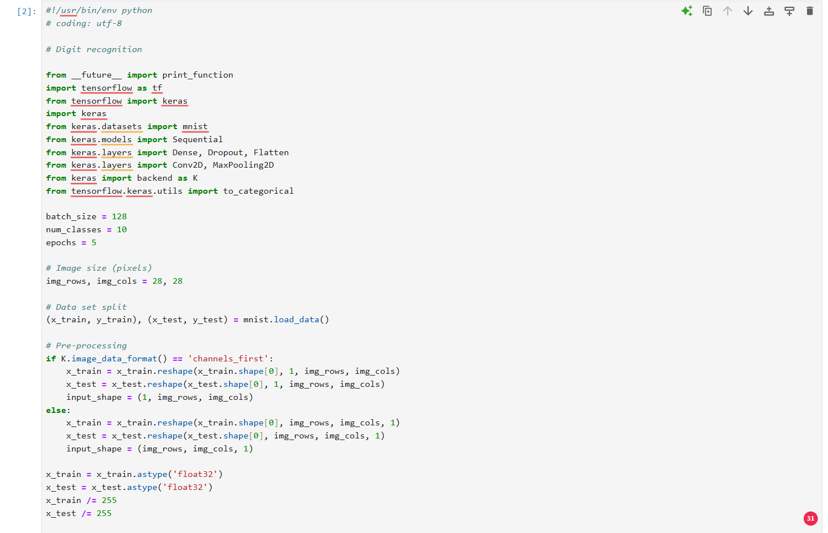
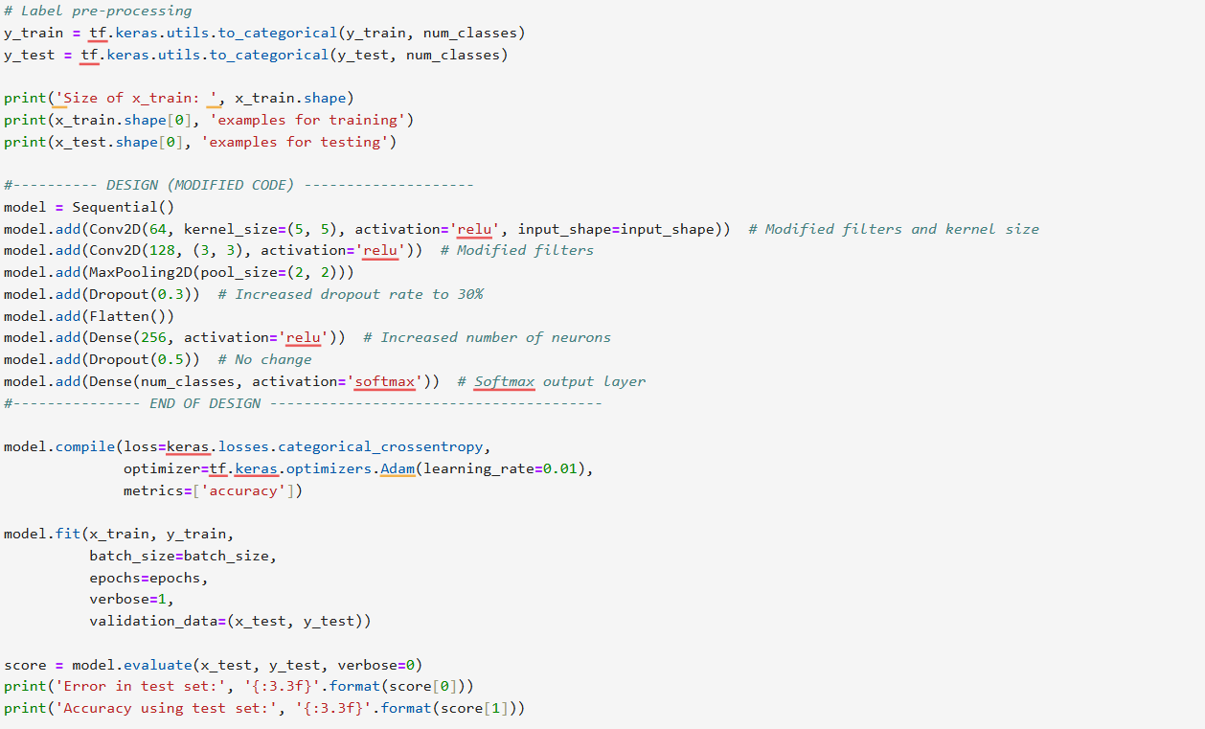
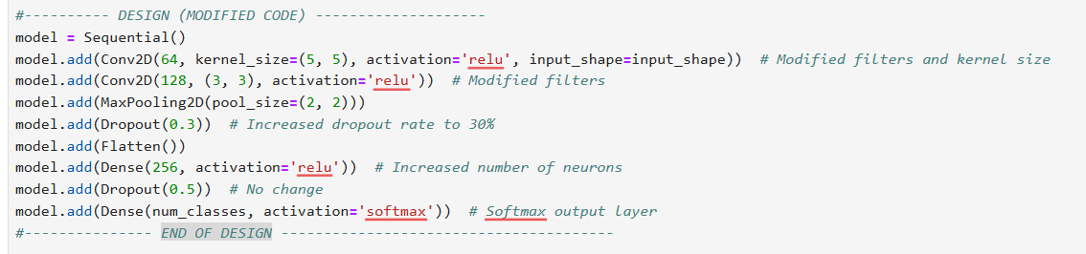

Screenshot (code execution)
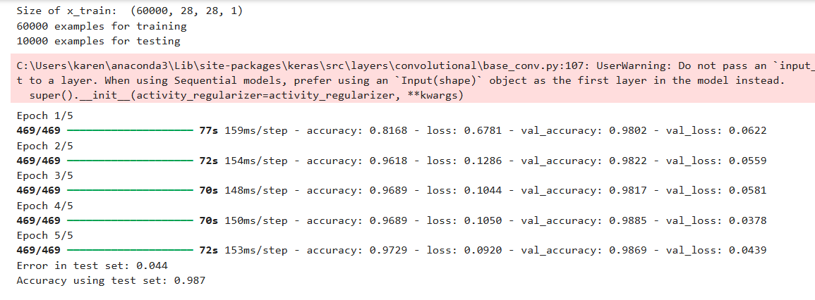

Accuracy: | Precisión utilizando el conjunto de pruebas: 0.987

Model 2
Code (design)
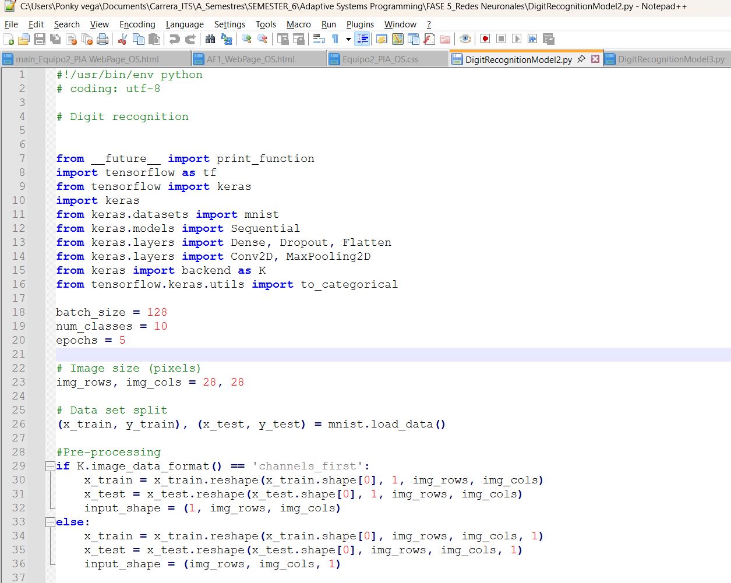
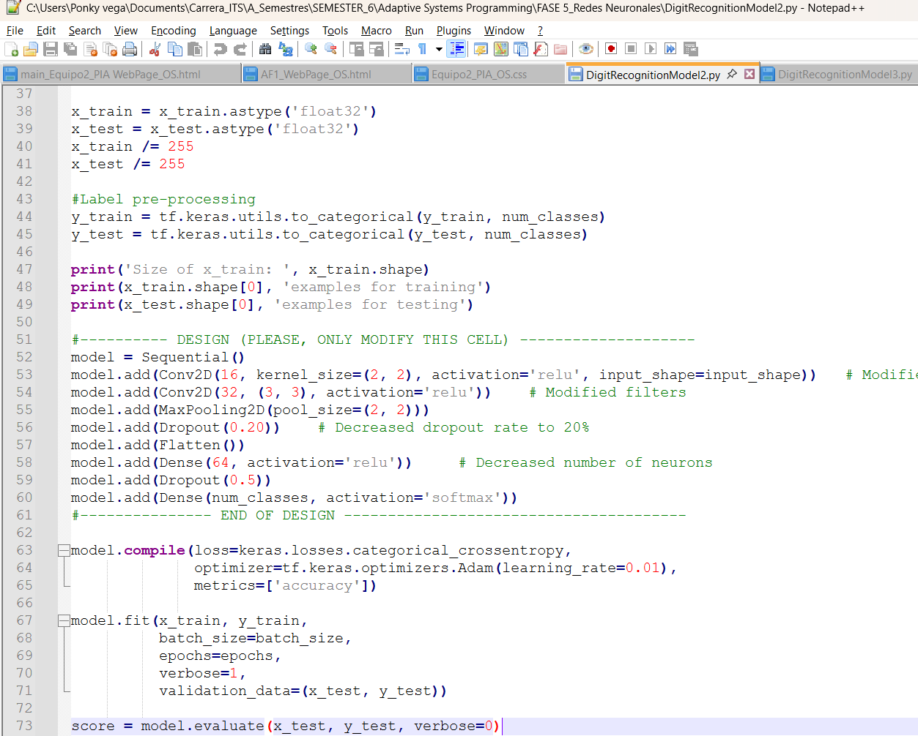
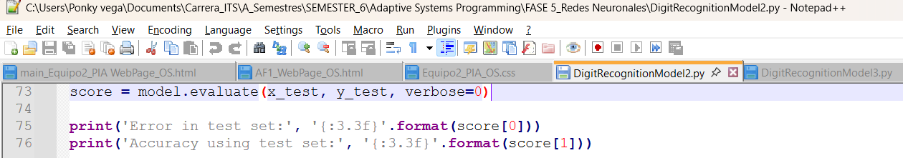

Screenshot (code execution)
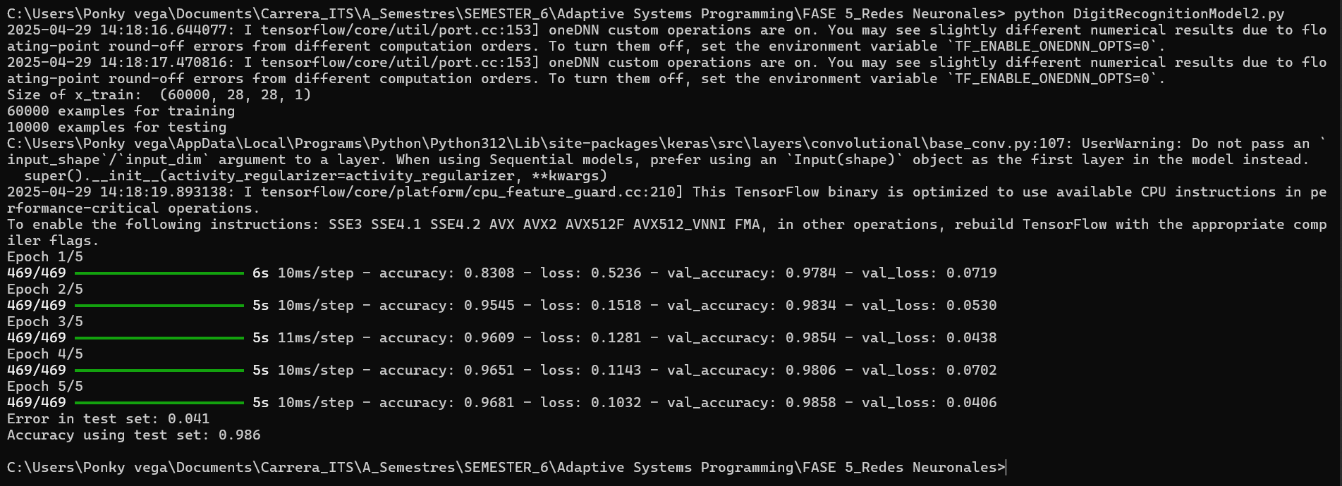

Accuracy: | Precisión utilizando el conjunto de pruebas:  0.986

Model 3
Code (design)

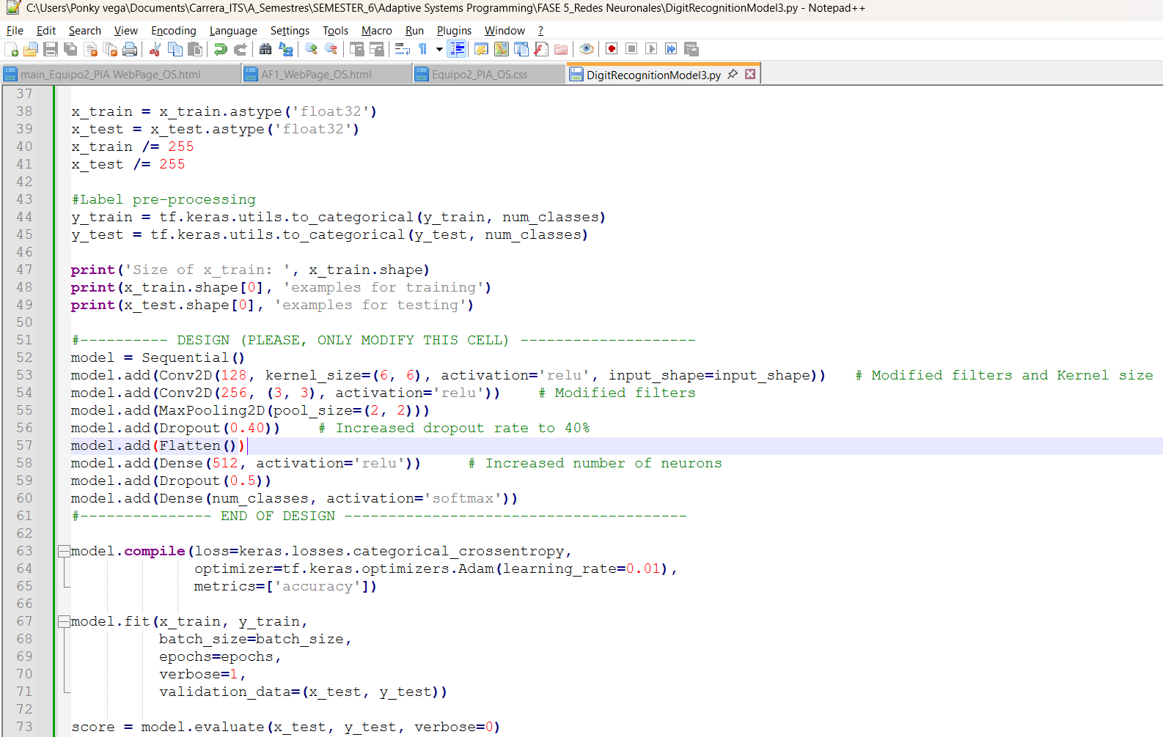


Screenshot (code execution)
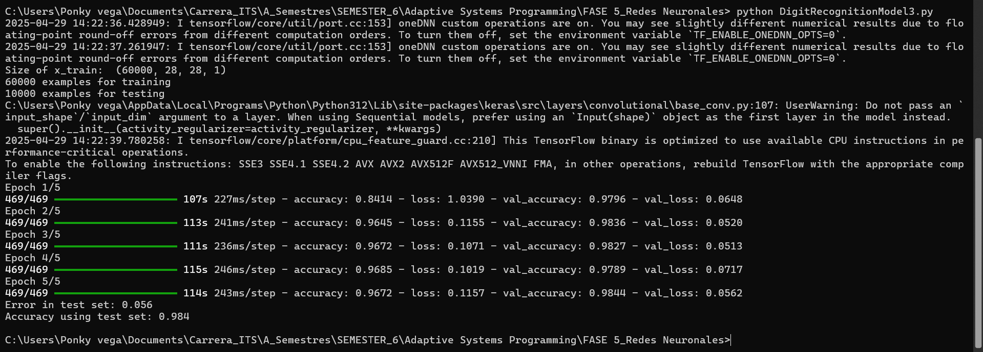

Accuracy: | Precisión utilizando el conjunto de pruebas:  0.984

Points

Concept | Points
R3.C1 (individual work) | 50
R3.C2 (teamwork) | 50
Total | 100

R3.C2
Exercises
Variable types | 10
Classification | 15
Multilayer networks | 15
Deep networks
Models: Code | 20
Models: Execution | 20
Models: Accuracy | 20
Total | 100

